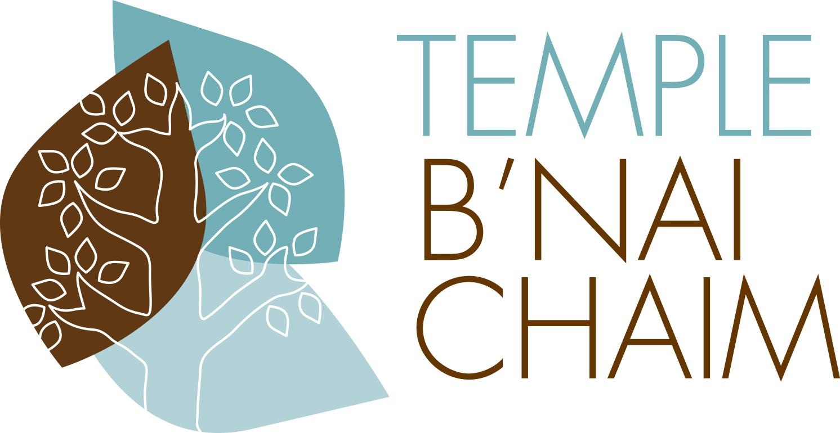
82 Portland Avenue, Wilton, CT 06897
TBC Art Sale Donation Sheet (PLEASE PRINT)
INSTRUCTIONS:
- Please complete the following form and attach it to the artwork being donated.
- Artists submitting their own work please include a brief narrative bio on a separate sheet and email to seventerriers@gmail.com.
- The donation sheet and bio should be received by TBC no later than March 18, 2021.
- Art should be brought to Temple B’nai Chaim on Monday, March 8, 2021, between 6pm and 8pm; Sunday, March 14, 2021 between 12pm and 2pm; or Tuesday, March 16, 2021 between 2pm and 4pm. If none of these dates is convenient for you, please call June Mara at (203) 610-2939 to make other arrangements. Leave a message including your name, when it is convenient for you to bring your art in and the best time to return your call.
Donor Name
Donor Address (Street, City, State, Zip Code)
Donor Phone and Email
Item Donated (circle one) | Painting Sculpture Pottery Other __________________
Artist (if known)
Sale Status (circle one) | Donation | Consigned
Donor’s preference if not sold (circle one) | Return to donor | Donate to the Turnover Shop  (with proceeds going to TBC)
Dimensions
Description (including location of artist’s signature; number if a limited edition, etc.)
Condition
Approximate Retail Value
Recommended Starting Bid
To be completed by TBC intake team
Piece Number
Photo | Yes | No
Auction Status (circle one) | Silent | Live
Bid Price | Starting  Increments  Buy Me Now | Starting
Actual Sale Price

